Development
Javac: we can use Javac to compile a single or group of “.java files”.
Syntax:
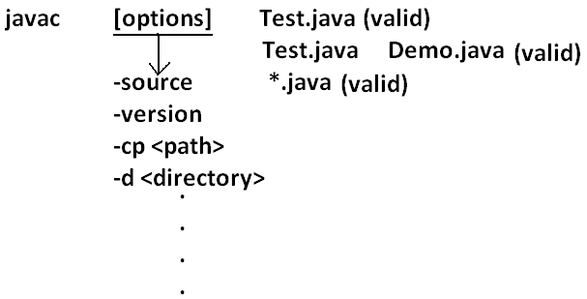
Java: we can use java command to run a single “.class file”.
Syntax:
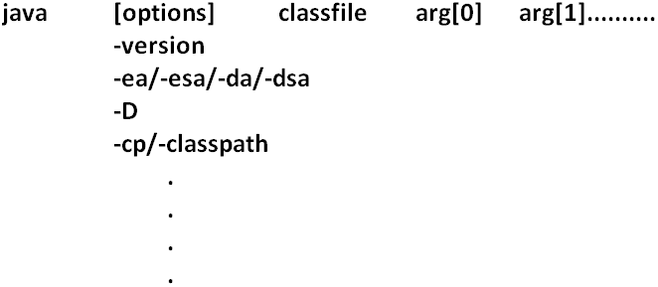
Classpath: Class path describes the location where the required “.class files” are available. We can set the class path in the following 3 ways.
- Permanently by using environment variable “classpath”. This class path will be preserved after system restart also.
- Temporary for a particular command prompt level by using “set” command.
Example:
- Once if you close the command prompt automatically this class path will be lost.
- We can set the class path for a particular command level by using “–cp” (or) “–class path”. This class path is applicable only for that command execution. After executing the command this classpath will be lost.
- Among the 3 ways of setting the class path the most common way is setting class path at command level by using “–cp”.
Example 1:
class Rain
{
public static void main(String args[]){
System.out.println("Raining of jobs these days");
}
}
Analysis:
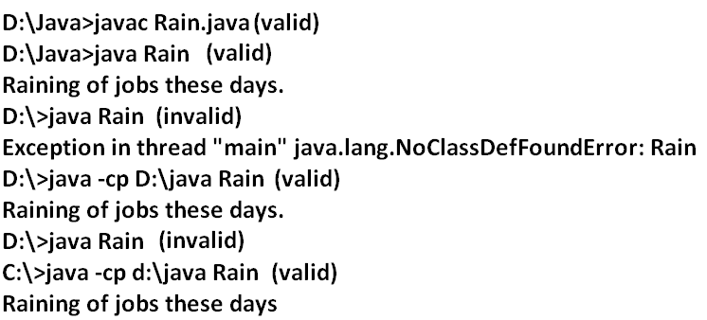
Example 2:

Analysis: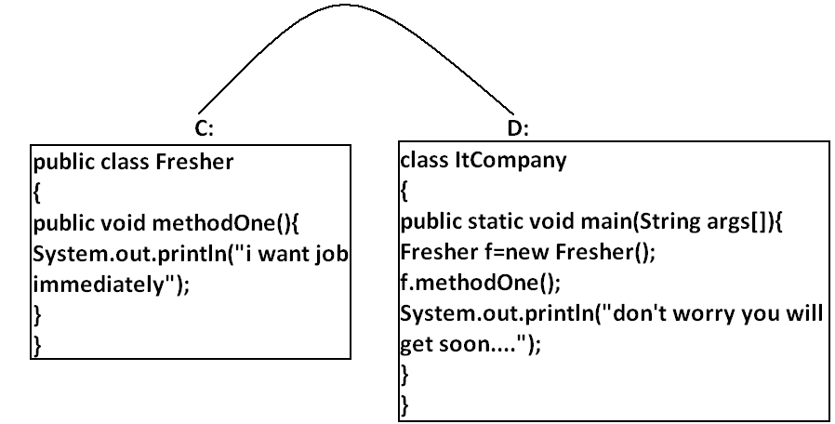
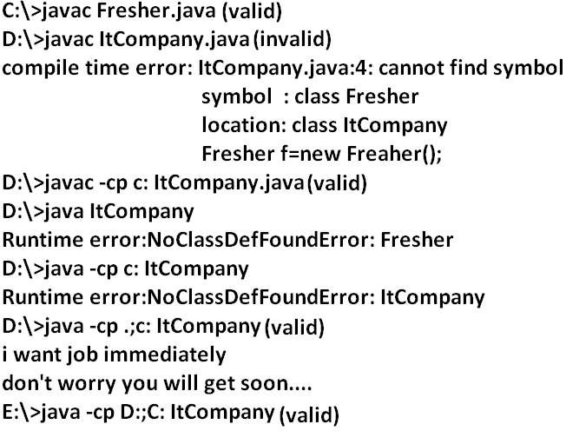
Example 3:
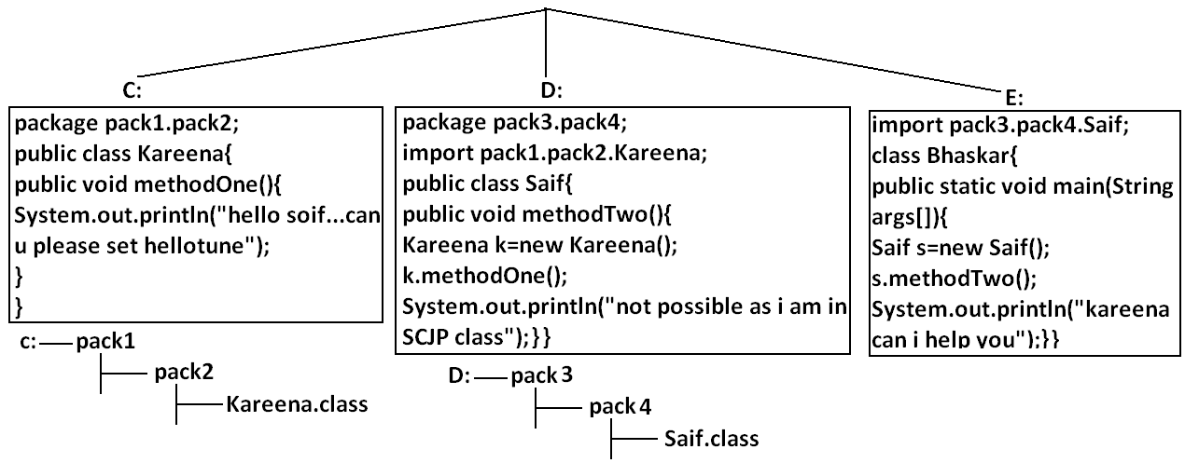Analysis:
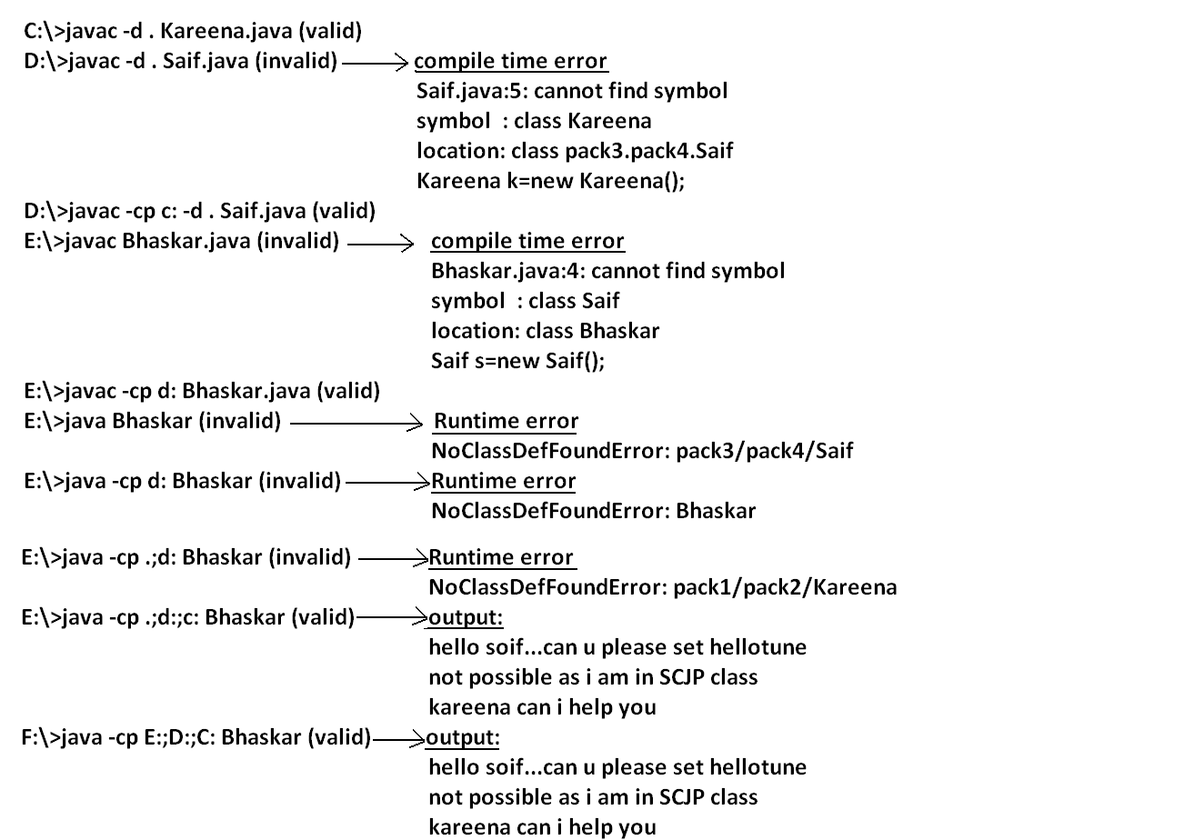
Note: if any folder structure created because of package statement. It should be resolved by import statement only and the location of base package should be make it available in class path.
Note: in classpath the order of locations is very important and it should be from left to right.

Example 4:
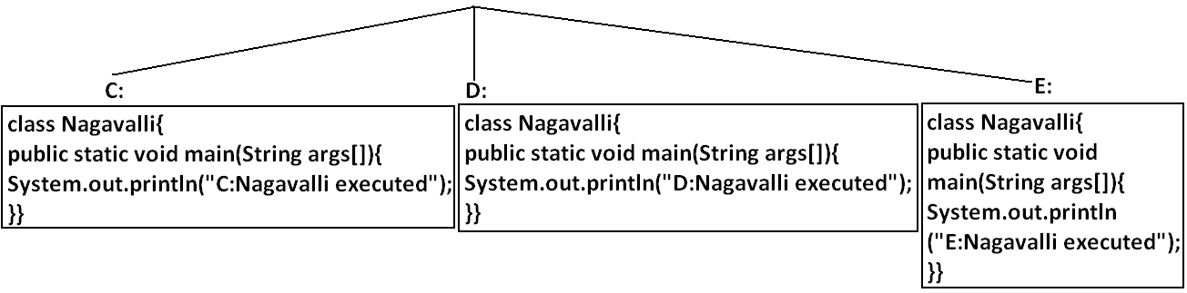Analysis:
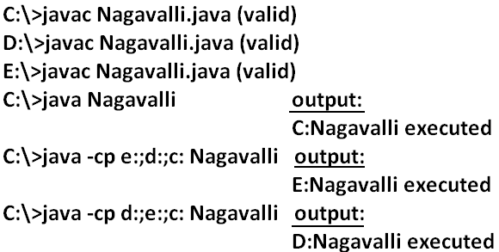
Jar file: If several dependent classes present then it is never recommended to set the classpath individual for every component. We have to group all these “.class files” into a single jar file and we have to make that jar file available to the classpath.
Example: All required classes to develop a Servlet are grouped into a single jar file (Servlet-api.jar) hence while compiling Servlet classes we have to make this jar file available in the classpath.
What is the difference between Jar, War and Ear?
Jar (java archive): Represents a group of “.class files”.
War (web archive): Represents a web application which may contains Servlets, JSP, HTML pages, JavaScript files etc.
Ear (Enterprise archive): it represents an enterprise application which may contain Servlets, JSP, EJB’S, JMS component etc.
- In generally an ear file consists of a group of war files and jar files.
Ear=war+ jar
Various Commands:
To create a jar file:
D:\Enum>jar -cvf bhaskar.jar Beer.class Test.class X.class
D:\Enum>jar -cvf bhaskar.jar *.class
To extract a jar file:
D:\Enum>jar -xvf bhaskar.jar
To display table of contents of a jar file:
D:\Enum>jar -tvf bhaskar.jar
Example 5:
public class BhaskarColorFulCalc{
public static int add(int x,int y){
return x*y;
}
public static int multiply(int x,int y){
return 2*x*y;
}}
Analysis:
C:\>javac BhaskarColorFulCalc.java
C:\>jar -cvf bhaskar.jar BhaskarColorFulCalc.class
Example 6:
class Client{
public static void main(String args[]){
System.out.println(BhaskarColorFulCalc.add(10,20));
System.out.println(BhaskarColorFulCalc.multiply(10,20));
}}
Analysis:
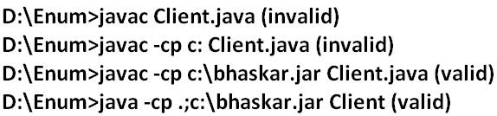
Note: Whenever we are placing jar file in the classpath compulsory we have to specify the name of the jar file also and just location is not enough.
System properties:
- For every system some persistence information is available in the form of system properties. These may include name of the os, java version, vendor of jvm etc.
- We can get system properties by using getProperties() method of system class. The following program displays all the system properties.
Example 7:
import java.util.*;
class Test{
public static void main(String args[]){
//Properties is a class in util package.
//here getPropertes() method returns the Properties object.
Properties p=System.getProperties();
p.list(System.out);
}
}
How to set system property from the command prompt:
- We can set system property from the command prompt by using –D option.
Command:
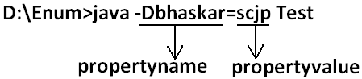
What is the difference between path and classpath?
Path: We can use “path variable” to specify the location where required binary executables are available.
- If we are not setting path then “java” and “Javac” commands won’t work.
Classpath: We can use “classpath variable” to describe location where required class files are available.
- If we are not setting classpath then our program won’t compile and run.
What is the difference between JDK, JRE and JVM?
JDK (java development kit): To develop and run java applications the required environment is JDK.
JRE (java runtime environment): To run java application the required environment is JRE.
JVM (java virtual machine): To execute java application the required virtual machine is JVM.
Diagram:
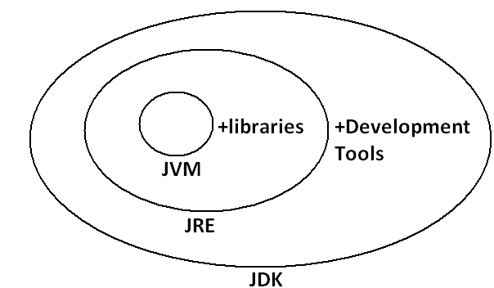
- JDK=JRE+Development Tools.
- JRE=JVM+Libraries.
- JRE is the part of JDK.
- Jvm is the part of JRE.
Note: At client side JRE is required and at developers side JDK is required.
Shortcut way to place a jar files:
- If we are placing jar file in the following location then it is not required to set classpath explicitly.
Diagram:

